**Language ARP - Additionally Resourced Provision**

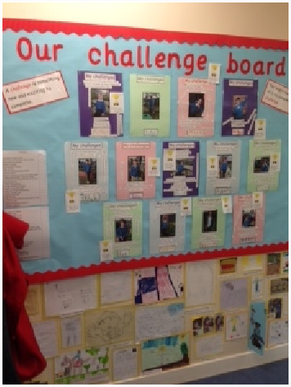

There is close liaison between staff in the Language ARP and the teaching staff with regular meetings and updates of the child’s aims and progress being made. Knowledge is shared about the nature of their speech and language difficulties and how the child’s work in class may be affected.

Strategies are discussed to enable the children to work to the best of their ability within their mainstream class.

The County funded Language Additionally Resourced Provision (ARP) has places for 15 children in Key Stage 1 and 2. Children in the ARP have a Statement for Special Educational Needs relating to **specific** Speech and Language difficulties. Their needs are met by the Language ARP team which includes a Specialist Language Teacher, Speech and Language Therapist and a number of experienced support assistants.

The children are all members of a **mainstream class**, taking part in lessons with their class. They are supported within class, the level of support depends on their educational and language needs. They are also **withdrawn** for specific work with the Language ARP staff. This can take the form of individual speech and language therapy, specialist teaching, or small group work. The children participate in **language groups** to develop specific areas of language, such as use of verbs or question words, but to also improve attention, listening, turn taking, and social language skills. All ARP staff are trained in Makaton signing and Cued Articulation and use these as appropriate.

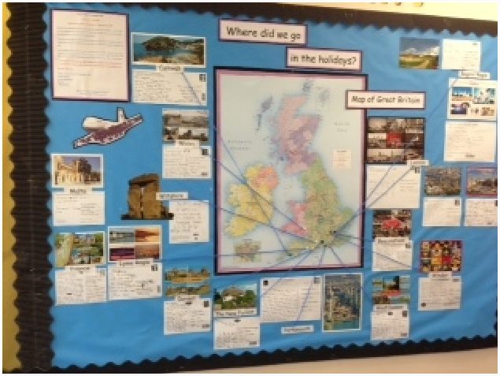

Staff from the Language ARP encourage strong links with **parents**.

* On a daily basis there is a home school book in which news and information can be communicated and questions can be asked and answered.
* Parents are invited to come into the ARP so that we can discuss their child’s **aims.** This would include their Speech and Language Therapy aims and the areas of reading, writing, numeracy etc. to be developed.
* Each year parents are invited to the child’s Annual Review. At this meeting the children’s progress is reviewed and future areas of development are discussed.
* Parents are welcome to come and observe their child working with the Speech and Language Therapist or Specialist Language Teacher.
* A ‘Parents Get Together’ is generally planned for each term. This may be an informal meeting where parents can find out more about what we are working on in the ARP and meet other ARP parents. Past meetings have included discussions about word maps and ideas for developing the organisation skills of the children. The meeting may take the form of a presentation by the ARP children, during which the children explain and demonstrate work they have carried out in the ARP. Most recently the children talked about what they had learnt in their ‘All About Us’ group. These presentations allow all children in the ARP to develop their confidence when speaking in front of an audience.
* The staff at the Language ARP encourage parents to support their children develop their speech, language, literacy and numeracy skills.

For more information or to arrange a visit please contact the school office.

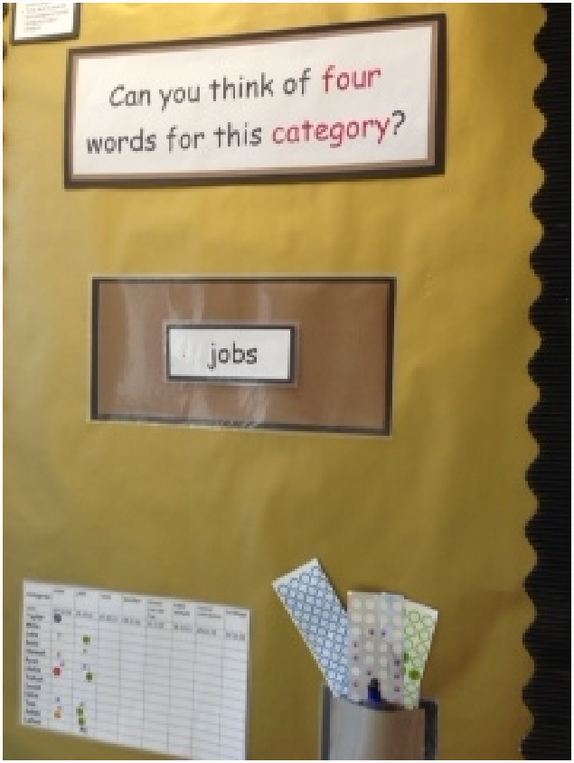

**Staff in Language ARP**: **Teacher in charge** Mrs S Rooke

**Speech and Language Therapist** - provided by NHS

**Support Assistants** – Mrs S Burnard, Mrs S Henry, Mrs N Hughes, Ms B Malkin, Mrs C Davis-Foster

**Informatio**n is also provided to parents regarding activities we are carrying out at school and ways they can help their child’s language

development at home